**UML-YANG Mapping Tool User Guide**

# Overview

The UML-YANG mapping tool translates a UML (Unified Modeling Language) model to a YANG model defined in RFC6020. The output YANG files can be conveniently used in REST style API definition.

# Mapping Rules

The mapping rules of this UML-YANG mapping tool is based on ONF onf2015.261_Mapping_Gdls_UML-YANG.04, IETF RFC 6020 and OMG Unified Modeling Language TM (OMG UML) Version 2.5.

# Programing Language

Programming language：JavaScript

Running environment: node.js

# Architecture and Components

Figure 1 illustrates the project structure of the UML-to-YANG mapping tool. The main functions and project entry is in the main.js, which uses UML files as input and generates yang files as output. The left side modules of the main doc.js relate to UML object classes extraction and analysis. The right side modules of the main.js relate to yang objects generation.

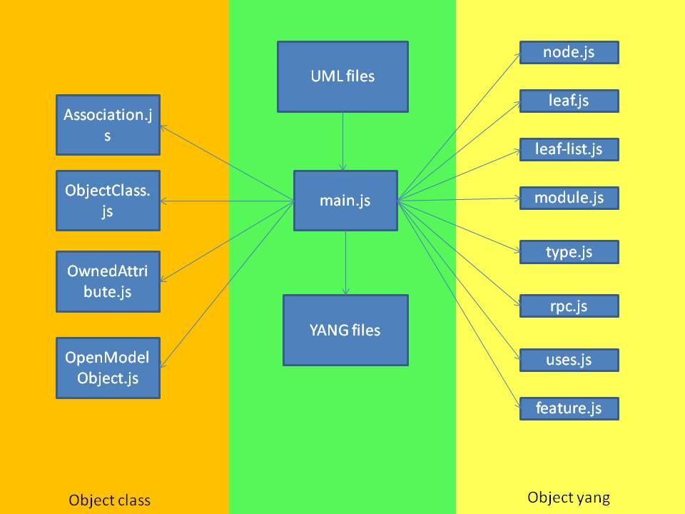

Figure 1 Project Files of UML-to-YANG Mapping Tool

Below is the description of the files and directories in the project.

* /main.js This is the project entry. This file contains main processing functions of UML to yang.
* /model This directory includes multiple files related to UML and YANG model.
* /model /Association.js This file extracts the “association” in UML file.
* /model /ObjectClass.js This file extracts “objectClass” in UML file.
* /model /ownedAttribute.js This file extracts the “ownedAttribute” in UML file.
* /model /OpenModelObject.js This file extracts the “OpenModelProfile” content in

UML file.

* /model /yang This directory includes the files related to yang elements.
  + /leaf.js This file translates the yang “leaf” node.
  + /leaf_list.js This file translates the yang “leaf-list” node.
  + /module.js This file translates the yang “module”.
  + /node.js This file translates the yang “node”.
  + /rpc.js This file translates yang “rpc”.
  + /type.js This file translates yang “type”.
  + /uses.js This file translates yang “uses”.
  + /feature.js This file translates yang “feature”.
* /project This directory includes UML files and the generated yang files.

# Implemented Mapping Rule

**Object Class mapping**

|  |  |  |
| --- | --- | --- |
| UML Artifact | YANG Artifact | remark |
| comment | “description” substatement |  |
| isReadOnly | “config”substatement | isReadOnly=true  config=false;  isReadOnly=false  config=true |
| abstract | "grouping" statement | abstract =true  can’t be Instantiated;  abstract =false  should be Instantiated; |
| support | “if-feature” substatement |  |
| condition |  |

**Attribute Mapping**

|  |  |  |
| --- | --- | --- |
| UML Artifact | YANG Artifact | remark |
| comment | “description” substatement |  |
| type | “type” substatement | built-in or derived type |
| isReadOnly | “config” substatement | isReadOnly=false  config=true;  isReadOnly=true  config=false |
| Multiplicity  (upperValue  lowerValue) | “mandatory” or “min-elements” and “max-elements” substatements [0..1] => no mapping needed; is default [1] => mandatory substatement = true [0..x] => no mapping needed; is default [1..x] => min-elements substatement = 1 [0..3] => max-elements substatement = 3 |  |
| defaultValue | "default" substatement |  |
| isOrdered | “ordered-by” substatement ("system" or "user”) |  |
| valueRange | “range” or “length” substatement of “type” substatement |  |
| passedByReference | if passedByReference = true 🡪 type leafref { path “/<object>/<object identifier>"  if passedByReference = false 🡪 either “list” statement (key property, multiple instances) or “container” statement (single instance) |  |
| support | “if-feature” substatement |  |
| condition |  |

**Type Mapping**

|  |  |  |
| --- | --- | --- |
| UML Artifact | YANG Artifact | remark |
| Primitive Type | Built-In Type if defined; |  |
| Enumeration | “enum” statement |  |
| Data Type | “typeDef” statement or grouping statement |  |

**Enumeration Type Mapping**

|  |  |  |
| --- | --- | --- |
| UML Artifact | YANG Artifact | remark |
| comment | “description” substatement |  |
| literal name | enum name |  |
| literal integer | “value” substatement |  |
| defaultValue | "default" substatement |  |

**Data Type Mapping**

|  |  |  |
| --- | --- | --- |
| UML Artifact | YANG Artifact | remark |
| comment | “description” substatement |  |
| type | “type” substatement(built-in type) |  |
| defaultValue | "default" substatement |  |
| ownedAttribute | The same as Attribute Mapping |  |

**Association Mapping**

|  |  |  |
| --- | --- | --- |
| UML Artifact | YANG Artifact | remark |
| generalization | “uses” substatement |  |
| aggregation =composition | “uses” substatement |  |
| aggregation=shared | “leafref” statement |  |

**Operation Mapping**

|  |  |  |
| --- | --- | --- |
| UML Artifact | YANG Artifact | remark |
| comment | “description” substatement |  |
| input parameter | “input” substatement |  |
| output parameter | “output” substatement |  |
| lifecycle stereotypes | “status” substatement | This artifact appears in OpenModelProfile and this work is in progress. |
| support | “if-feature” substatement | This artifact appears in OpenModelProfile and this work is in progress. |
| condition | This artifact appears in OpenModelProfile and this work is in progress. |

**Parameter Mapping**

|  |  |  |
| --- | --- | --- |
| UML Artifact | YANG Artifact | remark |
| comment | “description” substatement |  |
| Direction(in/out) | “input”/“output”substatement |  |
| type | see mapping of attribute types (grouping, leaf, leaf-list, container, list, typedef, uses) |  |
| multiplicity |  |
| defaultValue |  |
| complex parameter | “uses” substatement |  |

**Notification Mapping**

|  |  |  |
| --- | --- | --- |
| UML Artifact | YANG Artifact | Comments |
| common | “description” substatement |  |
| support | “if-feature” substatement | Support and condition go together. If the “support” is conditional, then the “condition” explains the conditions under which the class has to be supported. |
| condition |
| lifecycle stereotypes | “status” substatement | "current", "deprecated", "obsolete", default = “current” |
| attributes | see mapping of attribute types (grouping, leaf, leaf-list, container, list, typedef, uses) |  |
| complex attribute | “uses” substatement |  |

**Other Mappings**

|  |  |  |
| --- | --- | --- |
| UML Lifecycle | | |
| UML Artifact | YANG Artifact | Comments |
| Lifecycle Stereotypes | “status“ substatement | YANG: "current", "deprecated", "obsolete", default = “current”  UML: «Example», «Experimental», «Faulty», «LikelyToChange», «Deprecated», «Obsolete», «Preliminary» |

|  |  |  |
| --- | --- | --- |
| Interface | | |
| UML Artifact | YANG Artifact | Comments |
| Comment | “description” substatement |  |
| interface | Module |  |

# Not Implemented Mapping Rule

**Object Class Mapping**

|  |  |  |
| --- | --- | --- |
| UML Artifact | YANG Artifact | Reason |
| objectCreationNotification [YES/NO/NA] | “notification” statement | This artifact appears in OpenModelProfile and this work is in progress. |
| objectDeletionNotification [YES/NO/NA] | “notification” statement | This artifact appears in OpenModelProfile and this work is in progress. |
| operation | “action” substatement |  |

**Attribute Mapping**

|  |  |  |
| --- | --- | --- |
| UML Artifact | YANG Artifact | Reason |
| isInvariant | “extension” substatement 🡪 ompExt:isInvariant | This artifact appears in OpenModelProfile and this work is in progress. |

**Operation Mapping**

|  |  |  |
| --- | --- | --- |
| UML Artifact | YANG Artifact | Reason |
| pre-condition | “extension” substatement🡪 ompExt: preCondition |  |
| post-condition | “extension” substatement🡪 ompExt: postCondition |  |
| operation exceptions | “extension” substatement🡪 ompExt:operationExceptions |  |
| isOperationIdempotent | “extension” substatement🡪 ompExt:isOperationIdempotent |  |
| isAtomic | “extension” substatement🡪 ompExt:isAtomic |  |

# How to Run This Tool

Running the UML-YANG mapping tool takes the following steps.

* Step 1: Download nodejs from <https://nodejs.org/en/> , choose the latest version for your system.
* Step 2: Install nodejs by double click the "node-vxxx.msi" file. Use the default options are fine.
* Step 3: Open the terminal window in your system. If it’s Windows, run "cmd" to open the command line window.
* Step 4: In the command line, go to the directory you put "mapping tool". The format is “..\ AGLE-UML_YANG-Mapping-Tooling\xmi2yang tool-vxx”. For example, I put this tool in D: work\Github\EAGLE-UML_YANG-Mapping-Tooling\xmi2yang tool-vxx.
* Step 5: Type "npm install xmlreader" and if there are no errors you are good to run the tool.
* Step 6: The given uml files should be first renamed to .xml files and then copied to the "project" folder, e.g. “a.uml” should be renamed to “a.xml”. Note that if “a.xml” depends on other files, they need to be copied to the “project” folder as well.
* Step 7: Create a new file named “key.cfg” to the "project" folder if “key.cfg” doesn’t exist. Search for the “key” you choose in the UML model and copy the “xmi:id” value of “Class” that contains the “key” and “key” name to the key.cfg file with json format. Save “key.cfg”.

For example, most classes use “uuid” as key. So the user should search for “Class” contains “uuid” in the UML model. In current CoreModel, the user will have the following result.

*xmi:id="* *_iVJ1kI2wEeO38ZmbECnvbg " name="uuid"*

So the user writes the following content in key.cfg.

*[{"id":"_iVJ1kI2wEeO38ZmbECnvbg","name":"uuid"},{"id":"_k5nWYI2wEeO38ZmbECnvbg",name:"localIdList"}]*

If there are other key values, e.g. LocalIdList, the user should also search for that I the UML model and adds the content to key.cfg.

* Step 9: The user can use the following command under this directory to run this tool.

*node main.js*

* Step 10: After running the tool, the .yang files will be generated by the mapping tool.

# Recommendation

We suggest the UML element identifiers are named according to YANG syntax (refer to chapter 6, RFC 6020). YANG syntax is similar to that of SMIng (chapter2.1, RFC3780). The detailed suggestion is as follows.

* Each identifier starts with an upper-case or lower-case character, dependent on the kind of SMIng item, followed by zero or more letters, digits, and hyphens.
* All identifiers defined in a namespace MUST be unique and SHOULD NOT only differ in case. Identifiers MUST NOT exceed 64 characters in length. Furthermore, the set of all identifiers defined in all modules of a single standardization body or organization SHOULD be unique and mnemonic. This promotes a common language for humans to use when discussing a module.
* When identifiers from external modules are referenced, there is the possibility of name collisions. As such, if different items with the same identifier are imported or if imported identifiers collide with identifiers of locally defined items, then this ambiguity is resolved by prefixing those identifiers with the names of their modules andthe namespace operator `::', i.e., `Module::item'. Of course, this notation can be used to refer to identifiers even when there is no name collision.

# History

Version 1.0: Initial version.

Version 1.1: Fix some bugs in version 1.1.

Version 1.2::

* Support the notification mapping.
* Support the “support” and “condition” mappings.
* Support the “isOrdered” “valueRange” “passedByReference” mappings for attribute.
* Support the “lifecycle stereotypes” mapping.
* Flexible “key” adding function: the user can assign “key” value of an object by writing the “key” information in key.cfg file.
* Error alert function: cross-reference among “yang module” files.
* Translated undefined data types in UML to “string” type in YANG.
* Allow translation of some other heading format of UML file.
* Add some complex datatype mapping.
* Add the function that allow illegal characters to be translated to legal characters in YANG identifiers.